Report of the Meeting in Kubrat, Bulgaria
On Sunday, the 8th of May, we all arrived after a long journey. We had some time to settle down in the Hostel quite near to the school and the students were welcomed by the host families. The first dinner we had in a Bulgarian-French family with typical food of both countries.
On Monday the program starts with a welcome ceremony on the school yard an in the beautiful decorated European school. We saw a play about the legend of Khan Kubrat the founder of the Great Bulgarian kingdom.
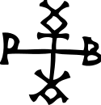His sign looks similar to the sign of Charlemagne of Aix la Chapelle.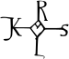
Since May 9th is Europe Day, we listened to a presentation on the 65-year history of the EU, which was followed with great interest. Here the link. Our countries have been part of the EU for very different lengths of time (DE, FR since 1957, TR associated member since 1965, PT since 1986, EE since 2004 and BG since 2007). The students and teachers could then write their wishes for the future of the EU on colored strips of paper. Afterwards we played some ice-breaking games and learned Bulgarian for beginners, which is doubly difficult with the Cyrillic alphabet. The students learned how to make typical Bulgarian pompom decorations for national costumes. That was only the program for the morning. After lunch at the school canteen, we all went for a tour of school and of the village together. Kubrat surprised with a lot of greenery, wide squares and green areas, tree-lined streets, old houses, few shops, horse-drawn carriages and almost no car traffic at all. Back at school, participants in a bicycle competition were already waiting for us to complete a skill course. The guest students were also allowed to participate. Dinner was with the school's art teacher in his hospitable house, adorned with works of art.
On the second day we all got into a beautiful bright yellow bus that was supposed to accompany us with its nice bus driver for the whole week. He maneuvers us in snaking lines around all potholes on country roads without side boundaries and without central reservations, but through ecologically very sensible wide hedges at the field edges. There was no need for a speed limit. We drove through a beautiful landscape to a 2,300-year-old burial ground of the Thracian kings and descended hundreds of steps to a sacred spring, which was home to a pilgrimage church and mosque. After we had completed all the customs and ablutions, we went up all the steps again! As every day, there was lunch in the school canteen in Kubrat, the food was very tasty. In the afternoon there was the obligatory reception at the mayor with an exchange of gifts. At school we discussed the project work on the topic of the preamble and the film scene.
- All coordinators with their teams and Erasmus clubs had translated the preamble and
- started with the Conferences for approval of the preamble.
- All countries had chosen the actors for the film scene and
- they had learned the text. So, the rehearsals could start on Thursday.
Another trip to a neighboring town with 400 inhabitants, where old ladies treated us deliciously and performed traditional dances and songs. At the end the girls were allowed to try on the old costumes. Very beautiful. In the evening we went to the Viva restaurant and felt like we had been here for at least a week.
On Wednesday we had a trip to Veliko Tarnovo and Ruse. First, we visited a rock church, then we drove about 2.5 hours to Veliko Tarnovo, the old capital of Bulgaria. This time, a tour of the fortress led us up countless steps to a church, which was artistically decorated and not used as a church. After a guided tour all over the picturesque old town, a very tasty lunch with a panoramic view waited on us. We took the opportunity to quickly buying a few souvenirs. Then we were taken to Mini-Bulgaria, after that everyone was really knocked out. In Ruse we walked along the Danube and the sun was already beginning to set. Back in Kubrat we ate a few small things in the Viva.
Things got serious on Thursday; we had a lot of project work ahead of us. The students had to rehearse for the film scene. Six actors from six countries had to play together. We agreed on the same type of implementation of the preamble in the six schools:
- No bookmarks with the preamble text,
- but the students preferred stickers with the keywords
  - Respect,
  - Honesty,
  - Freedom,
  - Acceptance and
  - Justice.
- Student should get one of the stickers at the beginning of the school year and other one to different opportunities.
- The Turkish proposal with a calendar sheet for all classrooms with the preamble text was also accepted.
- And as far as possible, a wall in the school should be designed with the preamble text inside or outside.
- In those schools that have a timer, agenda or calendar for the students the preamble should be a part of it.
- The students' art workshop on this topic was not very fruitful,
- so, we took over the already finished stickers from the Portuguese girl Maria Joao.
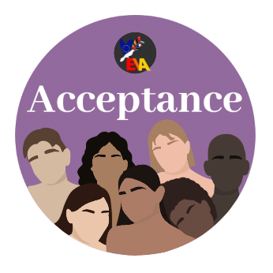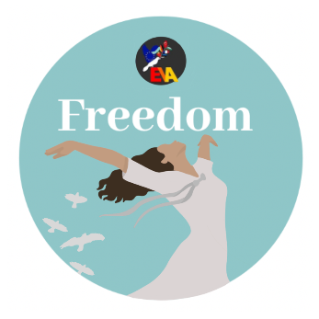

After lunch there was a workshop with a Roma representative on the behavior of witnesses of discriminatory behavior on social media. We discussed several typical situations and what is the best reaction on these daily offenses. The students learned Bulgarian dances and the teachers then worked on the final report.
- We discussed how to use the mobility tool and the number of travel and work days.
- Step 1: Coordinator's report, I think I can be ready until the end of June.
- Step 2: Correction, discharge and approval, please read carefully my report and tell me what I should add or correct. (Time line July or August)
- Step 3: Getting the report ready for submission
Once I have completed the partnership report, you should then finalise your own parts of the report. Your work consists of defining the details of your own budget, including the groups of participants you have sent to the project meetings. Once you have finished, you must indicate that you are also 'ready for submission'.
Only when all schools in the partnership are ready, I may proceed to the next step.
- Step 4: Submitting the joint partnership report
Once all partner schools have declared that they are ready, I will be able to submit the complete partnership report to my National Agency. The National Agencies handling the Grant Agreements with your partner schools will receive the reports of your partner schools at the same time.
- Important notes: It is very important to understand that the partnership must work together to submit the joint report. The National Agencies of partner schools are not going to be able to make payments before the joint partnership report has been submitted and evaluated by the coordinating National Agency.
- With the beginning of the next school year this all should be done.
In the evening we were entertained by Nina's niece.
The last day was also packed to the brim with a program. We first drove to Razgrad, the provincial capital. Some of the guests needed PCR tests for the return flight because they were not vaccinated. Then we met the deputy governor of the city in the plenary hall. The coordinators on the podium all looked very tired and the students played on their phones while the tireless Nina once again translated the structure of the government in Bulgaria and all other countries and the actual situation of refugees in our countries. Then we went to the training camp and to the stadium of the best Bulgarian football team. After lunch in the school canteen, the actors had to practice again, the others could go shopping. Everyone in town knew us and we were served in a very helpful and friendly manner. Then the film scene was recorded in the absence of the audience and then premiered with audience. The student’s discussion that followed revealed three different solutions to the conflicts in the workplace.
- To leave or
- to stay and fight for more acceptance
- or to leave and complain to improve the situation for other employees.
These possibilities were played improvised by the audience.
And then everyone got ready for the big final evening. In addition to the rich Bulgarian buffet, we set up our guests' dishes from Germany, France, Turkey, Estonia and Portugal. Then the Bulgarians started with their country-specific dances, songs and customs. Each guest country also had to perform something, sing or dance. Then we finally earned our certificates and other gifts. The time had come for the closing speech, in which I briefly and hopefully somewhat humorously reviewed the three years of the project. Our mission is completed, I think, and quite successfully too. On the meadow, dances awaited us that reminded the Estonians of midsummer. Girls in white dresses and wreaths of flowers danced to the great bonfire until little was left of it. Then there were real fireworks display and the brave were allowed to jump over the bonfire to ensure their health for the coming year. An incredibly beautiful conclusion to our project. The Bulgarians gave everything and even more cordiality.

