Report of our meeting in Resende
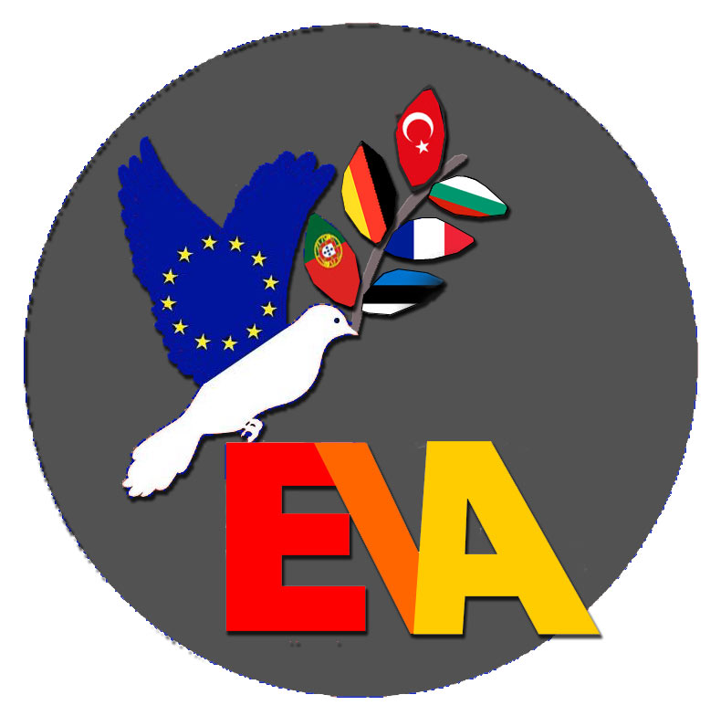
Resende, 5 December 2021

Arrival in Porto and transfer to Resende

Resende, 6 December 2021

Welcome to the School with music and dances, welcome speeches and ice-breaking games, a Portuguese lesson, lunch and a guided tour through the school, getting to know each other, presentations of migrants in Portugal, twin cities in Turkey/Syria and wall and borders from Germany. And at last we visited the beautiful town hall and had a reception with the major.

Resende, 7 December 2021

After a meeting with migrants from Brazil, who told us their stories, we saw the different scenes about discrimination from all our countries an discussed them briefly. After lunch there was an workshop with a very motivating member of the Red Cross from Porto. This was s day full of impressing work on our topic.

Resende, 8 December 2021

Excursion to Guimarães (European Capital of Culture in 2012): Castle, Palace of the Dukes, Old Town: Largo da Oliveira, Igreja de Nossa Denhora dos Passos. We learned a lot about the history of Portugal and about the Portuguese culture.

Resende, 9 December 2021

We started at school with a workshop about values, sended by birds to the whole world. Then student had the opportunity to join some lessons and teachers talked about the work for our common preamble.

Work on the preamble

1. Installing the preamble in our different schools
The process of ratification varies in our different countries. In most cases a certain group/a council, comprising teachers, headmaster, parents and student representatives, decide about the preamble. In some countries, local authorities or community representatives are involved in the process.

2. Work to be done before the meeting in La Reunion
Each EVA-team - except Portugal, where this already has been done - talks about important values with the students (and perhaps the teachers and parents) in their school. Not necessarily the whole school, but a few representative classes should be involved. Students should not just be given a list of values to vote from – as this could lead to unreliable results. Thus, discussions are really important.
Each team has to come up with five values that most students (teachers, parents…) agreed on.
We should also try to find good, understandable ways of expressing these values. The sentences should not be too complicated, but the message not too simple. (This is the hard part!)
There were suggestions that the sentences can be proverbs, but it remains to be seen, if this works in the English translation.
Other ideas were a kind of pledge/oath or creating an acrostic*.

3. Work in La Reunion
In the next meeting, the main task will be trying to agree on the most important values and finding a way of expressing them. A final version should be drafted, that (hopefully) finds the approval of all those responsible for the ratification of the preamble in our different schools.
There will be two workshops in La Reunion: one which should result in finally writing the common preamble, and the second focussing on an artful way of presenting the preamble.
The aim is to make it visible for everybody and make students, teachers and parents identify with it.
First ideas ranged from bookmarks to works of art displayed in the entrance hall.

* For those who do not know, what an acrostic is, let me give you an example:
Everybody is different from everybody else.
Various people have various life stories.
All of them are equally valuable.

After lunch the students and some teachers went to the municipal museum of Resende while the coordinators met again.

Summary of coordinators´ meeting

1. Corona
Aline will send the current regulations one week before the scheduled meeting, so that the necessary tests can be taken/booked in advance.
The programme in La Reunion should allow for some time to do a PCR-test, in case it will be obligatory before returning to the respective countries.
The Turkish delegation will probably spend one night in Paris. Twin room at the airport hotel: 63 € (according to Aline), taxi to the city centre: 20 minutes, 20-30 €

2. La Reunion
Aline has suggested the Cap Sud Hotel: 60 € for double or single room, breakfast: 7 €, can be cancelled two weeks in advance, otherwise the payment must be made two weeks before the arrival. Aline will send the details for the bank account.
No overnight stay in another place is necessary. The arrival on the island will be on Sunday morning.
Money can be calculated for 6 days for all those travelling to La Reunion, although there are only 5 working days. Work from Monday to Friday. On Saturday in the morning there will be a visit to a market, before going to the airport in the afternoon.
We agreed on each delegation paying an extra of (round about) 50 € per participant (teachers and students) for the programme activities. But that depends on extra costs for PCR-Tests, if necessary. Aline will let us know about the exact costs.

3. Kubrat
The meeting is planned for 8 – 15 May 2022. The best airport to travel to is Varna, 2nd best: Bucharest, Romania (NOT Sofia!). If all delegations landed in Varna, it would make transfer to Kubrat easier.

4. Theatre
We agreed on a two-fold strategy: first, we will “save” everything we have got so far: The German scene, that was performed in Resende, will be filmed and a compilation of all films (including the portraits of German students) should be made. Thus, we will have a product, even if performing on stage should not be possible.
Nina will prepare the Bulgarian scene with her students (part-time job/different kinds of discrimination). In Kubrat all students, after having watched the scene, will work in multi-national groups and improvise an ending to the scene. (Language help will be provided by the teachers.) After their presentations the different approaches shall be discussed. The “best version” will then be rehearsed again, so that finally there will be a coherent scene with actors/actresses from different nations.

After this hard day of working, we had an exceptional Farewell party at school. The mood was exuberant, warm and also a little sad that the week was almost ahead. The Bulgarian, Portuguese, Turkish and Estonian groups performed typical dances of their countries and French and German groups sang songs with all together and after a Portuguese dinner we had desserts from all countries.

Resende, 10 December 2021

On Friday we spend our last day together in Porto for Covid tests, visiting a museum and several churches and places we had a wonderful time at the Duoro.

